Clinic Booking Form
Please complete and email with your deposit to: Australian Equine Behaviour Centre
3 Wonderland Avenue, Tuerong 3915
Ph 0448 222 633
Email: admin@aebc.com.au
Web site: www.aebc.com.au

DATE OF CLINIC – Please write

TYPE OF CLINIC – Please write

I acknowledge that horse riding has associated risks, and I understand that The Australian Equine Behaviour Centre accepts no liability for any accident, injury or illness to horses, owners, riders, spectators or any other person or property whatsoever whether caused by negligence or not.

(YOUR SIGNATURE OR RIDERS GUARDIAN If under 18 years old)
Amount:
Card number:
Expiry:
Card Holder Name:
Signature:

Please debit the balance 1 week prior to clinic ☐
I will arrange to pay the balance 1 week prior to the clinic ☐
Please note: Clinic times, groups and food lists (if applicable) will be posted on the AEBC website ‘News & Events’ section 48 hours before the commencement of the each clinic, participants are required to check their own times. If you are unable to access the internet please call the office during business hours.

Name of Rider Age (if under 18)

Address

State Postcode Phone

Email Mobile

Standard of horse/rider combination: Dressage level ___________ Dressage Only   Jumping (Comp/PC grade ) _____________ Confidence level: High/Medium/Low ___________

Name of horse: Age of horse: Mare/Gelding/Stallion

Have you attended an AEBC clinic before? (Please circle) YES NO

Please specify if you would like to be grouped with friends (at the discretion of clinic organizer)

EMERGENCY & MEDICAL INFORMATION- Ambulance will be called for any injury

Allergies / Dietary Requirements/Current Medications?

Are there any relevant health problems we should know about - please attach

Emergency Contact & Phone

COST BREAKDOWN (All prices include GST)

Horse – yard $15 per day/night x days = $

Stable (with shavings) $40/ Day x days= $

Shavings - $20 per bale 1 or 2 bale= $

Accommodation – bunkroom $25 per night per person x nights = $

Own accommodation – i.e. truck or float $15 per night per person x nights = $

Cost of clinic x days = $

TOTAL $

DEPOSIT $50 non-refundable (booking not secured until deposit paid & form received) $

BALANCE OWING 1 WEEK PRIOR $
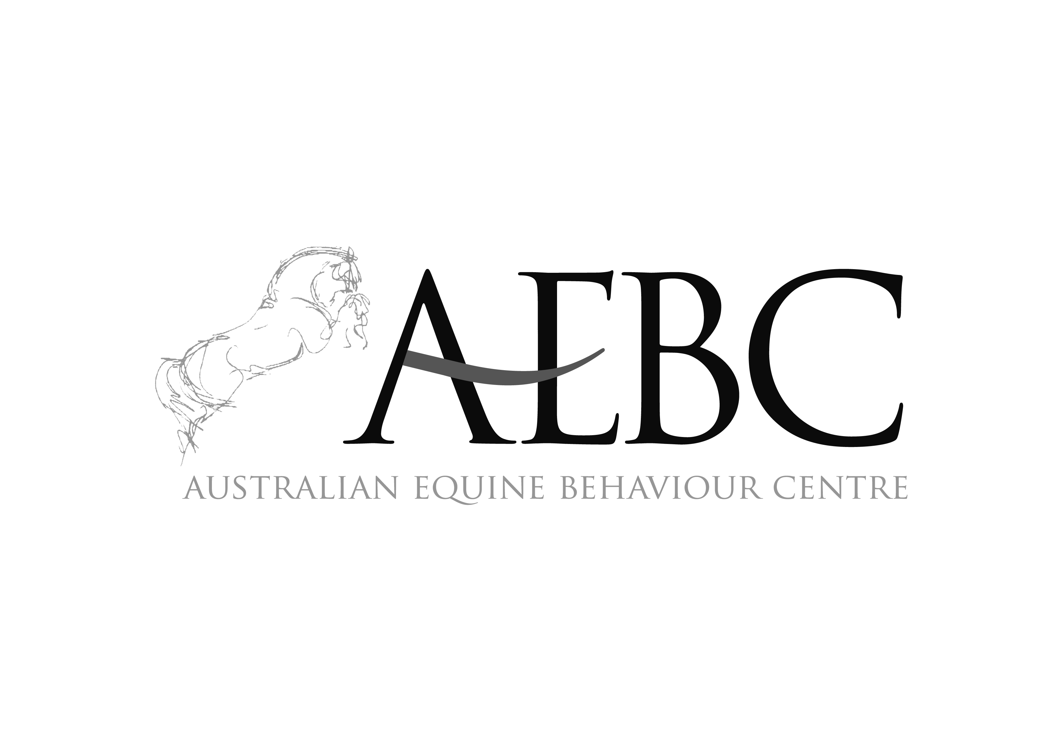

Clinic Formats
To confirm your place, please send your form along with a $50 non-refundable deposit. We require full payment to be made one week prior to the clinic.
Your place in the clinic is not confirmed unless your form & deposit is received!

Lessons include combinations of ground work, active riding, dressage, show jumping and x-country. Lecture topics include psychology, behaviour, application of the aids, biomechanics, and learning theory. Demonstrations show the application of the above in ground work, foundation training as well as more advanced training.

ADULT CLINICS 1 x Private & 1 x group lesson per day, plus demonstration.

YOUNG RIDER CLINIC: 2 X 1hr group lesson plus lecture or demonstration daily

INTENSIVE CLINICS 1x private lesson + 1 group
session daily.

What To Bring
Please BYO bedding, all requirements for your horse including buckets, and bathers in summer. Fully equipped kitchen and BBQ Facilities are available. Participants of Adult and Intensive clinics arrange all their own meals. For weekend Adult clinics there is the option of going out for dinner. For evening meals at Pony, Junior and Young Rider clinics there is a pool of food (you will be advised what to bring), and you are required to supply their own breakfast and lunch. Clinic times, groups and food lists will be posted on the AEBC website ‘News & Events’ section 48 hours before the commencement of the each clinic, participants are required to check their own times. If you are unable to access the internet please call the office during business hours for your times.

How Much
Adult Clinics $ 145 per day
Suitable for riders 16 years and over of all standards. Junior riders may apply.

YOUNG RIDER CLINICS $ 120 PER DAY
Suitable for riders ages 12+ competing at pcav levels 3-1

Intensive Clinics $ 145 per day
Suitable for riders 16 years and over of all standards. Junior riders may apply.

We will do our best to accommodate special requests but please include them on your form!

Clinics 2019

- Science based, ethical, sustainable training
- Suitable and effective for riders and horses of all levels
- Logical and easy to apply
- Produces relaxed and obedient horses

